**COMPLEX ENGINEERING PROJECT**

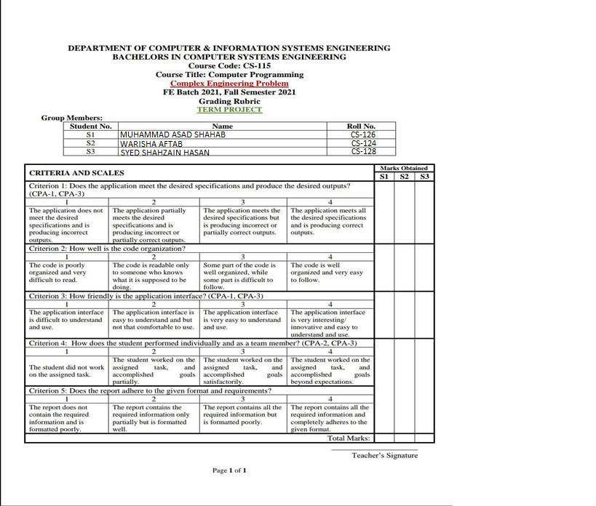

***PROBLEM DESCRIPTION***

The problem assigned was to develop a program commonly called as a “Quiz Game” and assigned name was “Complex Engineering Problem”. The problem or project had be developed having two portions initially. First one, the player. In player mode, a person can play a game or quiz in different branches and can test him/herself. Second one was of administration part. A person selecting administration part can will have two options further. He or she can view the whole quiz for satisfaction also, he or she can edit the questions. It was also required that the quiz should consist of two or more topics and a user can select one desired. Then comes the difficulty selecting interface where the user can select hard, easy or medium level and the questions will appear respectively. At the end of player portion, the program should print the score of an individual.

***DISTINGUISHING FEATURES OF YOUR OBJECT***

The distinguishable features of our project contains the “Graphical User Interface” rather than being stuck with the “Command Line Interface”. The user is facilitated with the “Mouse-selecting facility” to make it more user friendly rather than typing a command from keyboard which subsequently makes it more pleasing. Then comes the designing phenomenon in which user is entertained with various colors on the buttons to not to lose interest and, to please the user’s eyes, the most sophisticated background themes are selected in accordance with the domain he or she is willing to choose.

We have also made the file as executable using PyInstaller so the user can facilitate even if he doesn’t have a python interpreter installed.

***FLOW OF THE PROGECT***

1. ***PLAYER***

If you select player part, it will then display the three domains. The user will select the desired domain and the difficulty level will appear. Consider you have selected the domain Physics and now you select medium then, the medium difficulty level questions will appear and in the end, it will just simply calculate your result.

1. ***ADMINISTRATOR***

When you select the administrator part, it will give you two options to choose a single. It consists of “View as an administrator” or “Edit the questions”. If your select the view part, the questions will appear one by one and you can only view the questions. If you select the edit part, then the administrator can also edit the questions as well as add new questions.

PLAYER

HARD

EASY

COMPUTER

PHYSICS

HISTORY

MEDIUM

MEDIUM

HARD

MEDIUM

EASY

EASY

HARD

ADMINISTRATION

SIGN UP

SIGN IN

VIEW QUESTIONS

EDIT QUESTIONS

HARD

EASY

COMPUTER

PHYSICS

HISTORY

MEDIUM

MEDIUM

HARD

MEDIUM

EASY

EASY

HARD

***MOST CHALLENGING PART***

Without a second’s thought, the ADMIINISTRATIVE part was the most challenging part in which, editing questions proved to be a hectic job. But with the help of Almighty, we encountered this trouble. Besides this administration part, implementing GUI also took our most concentration because we were not so familiar with it. Although it took almost all the time but, this is what you call “Learning”.

***NEW THING(S) LEARNT IN PYTHON***

It will not be wrong if we say that only “Functions” and a very few structures we used were taught previously. The rest of whole techniques are included in the list of new learnings indexing 0= Mouse-selection to indexing -1=Buttons commands. This list further contains the managing of buttons and label’s co-ordinates on the display screen. It also includes the color implementing process. In a nutshell, the whole designing. Learning GUI from “TUITORIALS POINT” was a remarkable experience. Up till now, we were having the “Spoon feeding terminology” but, this project enhanced our capability to not to rely on learnt techniques but to explore other phenomenon as well. We learnt about various kinds of appearing boxes like Radio Buttons, Labels and checks etc.

***INDIVIDUAL CONTRIBUTIONS***

**Asad (CS-126)**

The player part was programmed by Asad Shahab. He not only did his part, but also corrected the mistakes or errors arose in other’s parts as well.

**Warisha (CS-124)**

The edit questions part inside the administration was programmed by Warisha Aftab. She also helped in making the view questions part and in designing.

**Shahzain (CS-128)**

The view questions part inside the administration part was programmed by Shahzain Hassan. He also helped his group in making the report and communicated the problems to the respective instructors.

***FUTURE EXPANSIONS***

To be very honest, this project and specially the appearance of this project was very new for us and it gave us the joy when we saw it completed. Since it pleased us then, there is a probability that other people may also like it. It is a good opportunity to cash on. We intend to take it on business level. With some more deep learning or enhancement, we will take it to free lancing platforms like “UP WORK” and “FIVER”. Since it has provided us the very basic spark, it seems like it will be the never stopping journey.

***LIST OF REFERENCES***

1) Tutorials Point

2) YouTube

***TEST 1***

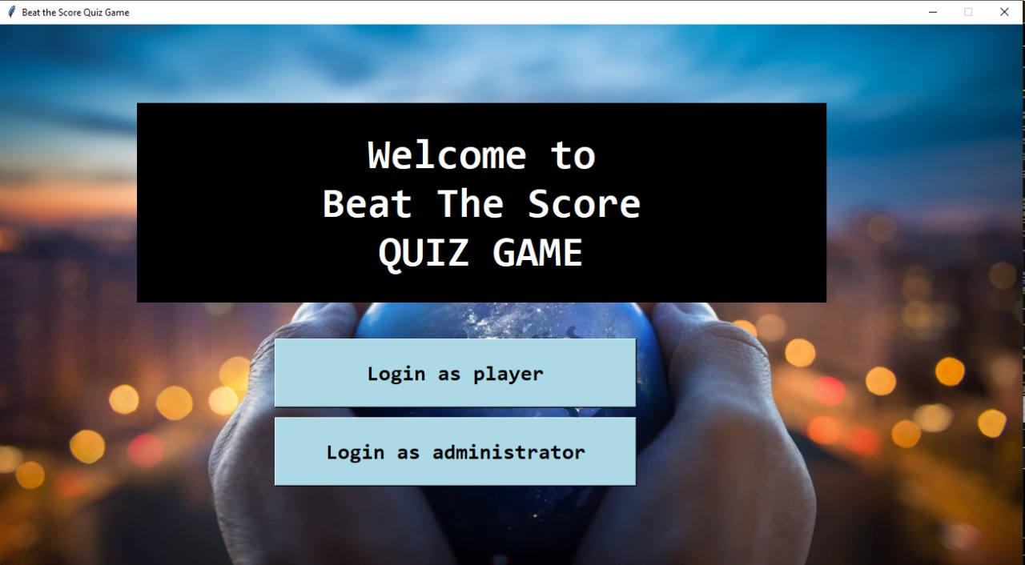

***TEST 2***

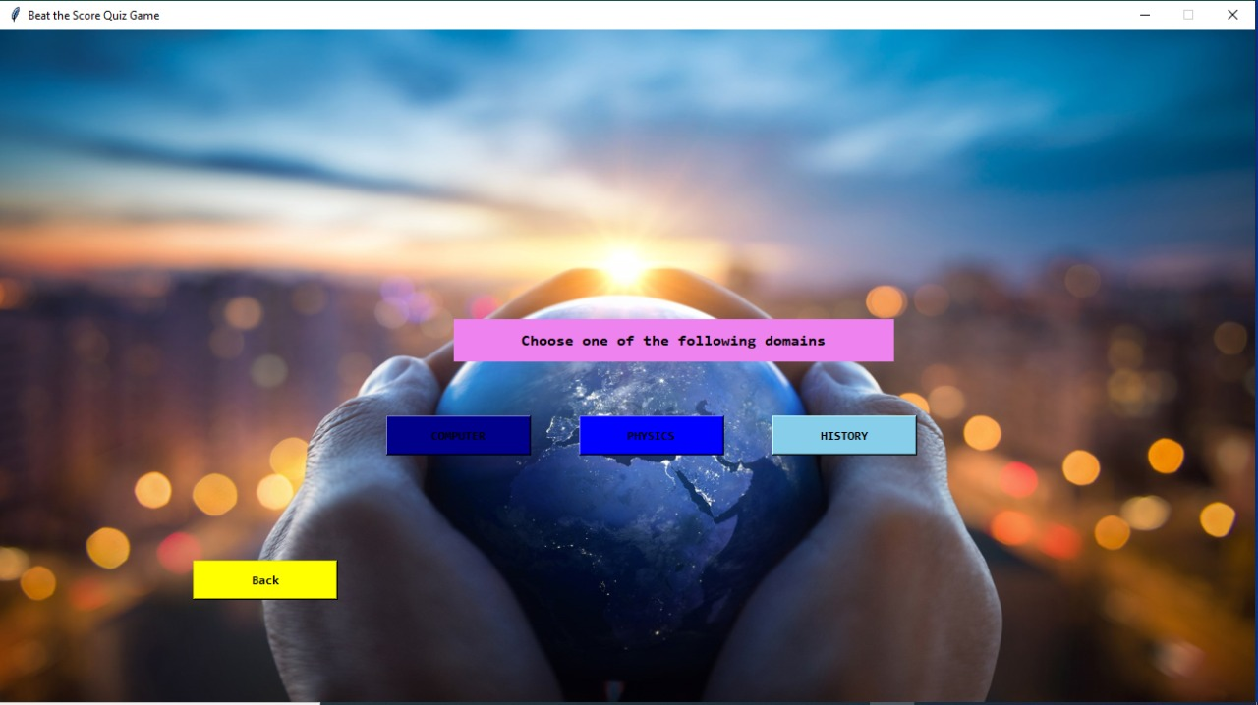

***TEST 3***

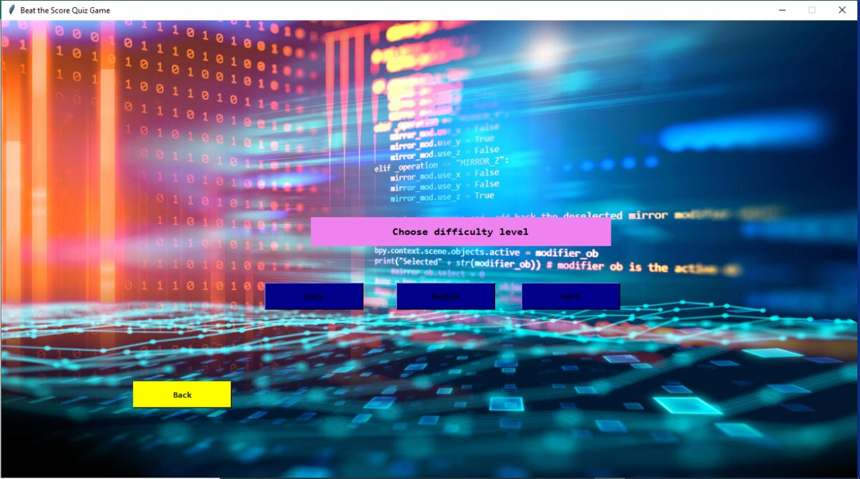

***TEST 4***

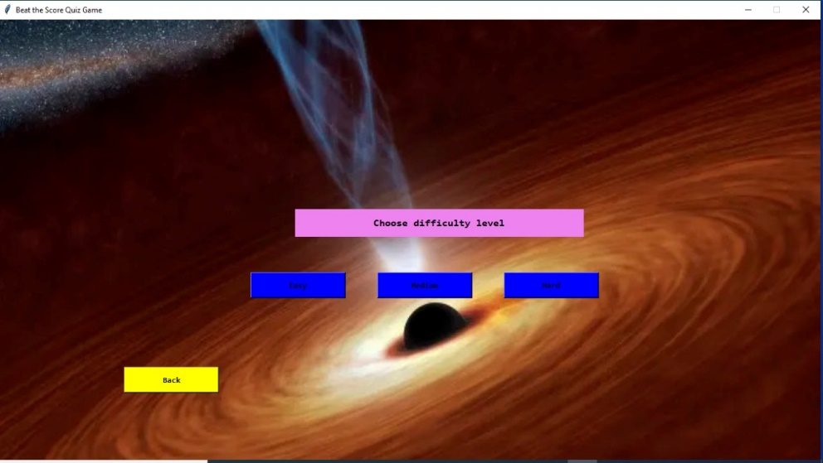

***TEST 5***

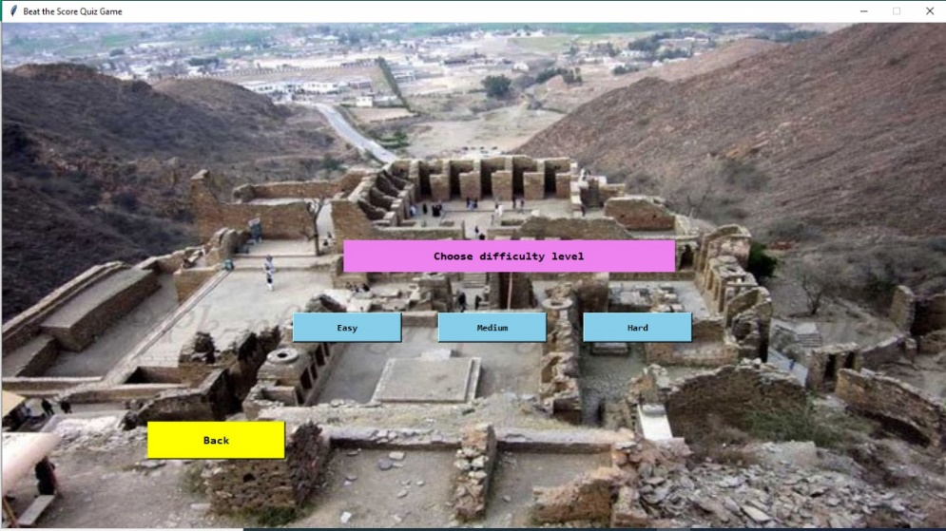

***TEST 6***

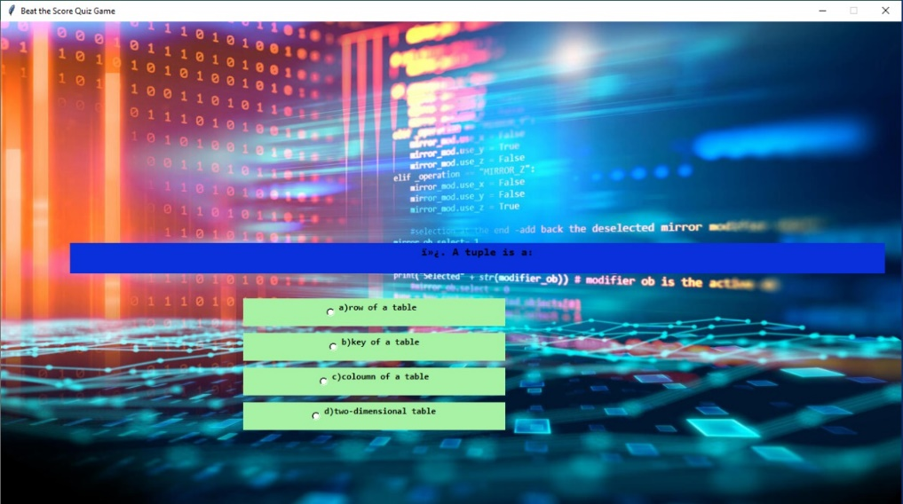

***TEST 7***

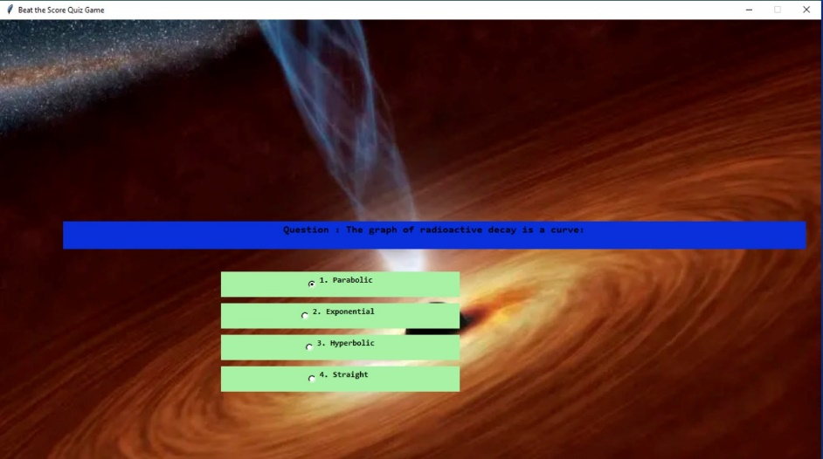

***TEST 8***

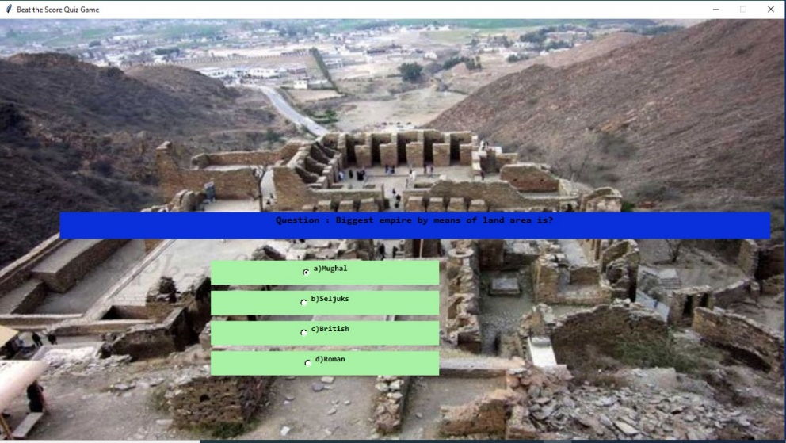

***TEST 9***

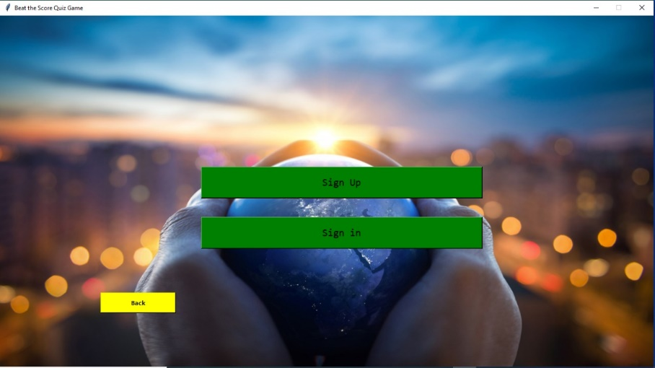

***TEST 10***

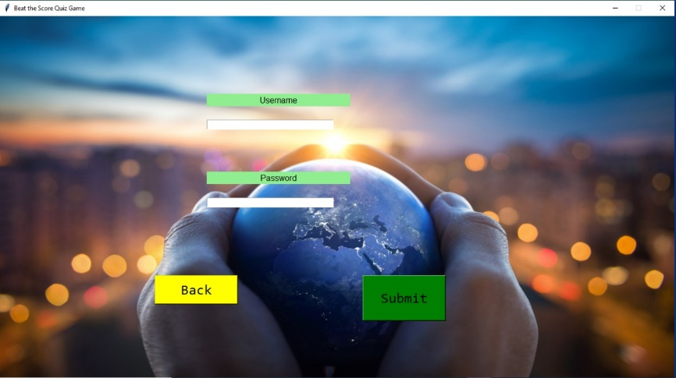

***TEST 11***

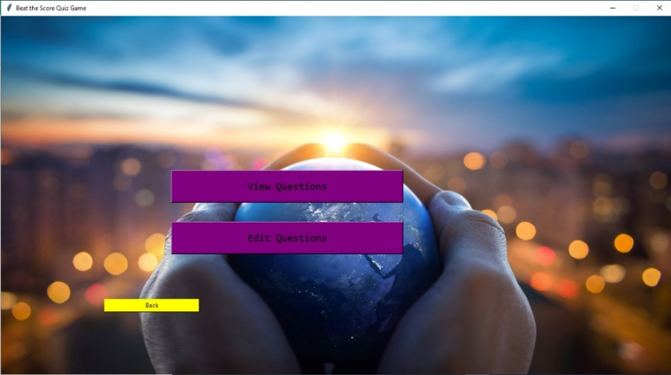

***TEST 12***

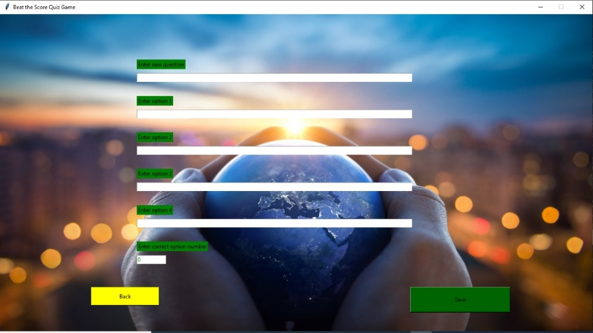

***TEST 13***

